# Question

Every email consists of a local name and a domain name, separated by the @ sign.

For example, in alice@leetcode.com, alice is the local name, and leetcode.com is the domain name.

Besides lowercase letters, these emails may contain '.'s or '+'s.

If you add periods ('.') between some characters in the **local name** part of an email address, mail sent there will be forwarded to the same address without dots in the local name.  For example, "alice.z@leetcode.com" and "alicez@leetcode.com" forward to the same email address.  (Note that this rule does not apply for domain names.)

If you add a plus ('+') in the **local name**, everything after the first plus sign will be **ignored**. This allows certain emails to be filtered, for example m.y+name@email.com will be forwarded to my@email.com.  (Again, this rule does not apply for domain names.)

It is possible to use both of these rules at the same time.

Given a list of emails, we send one email to each address in the list.  How many different addresses actually receive mails?

**Example 1:**

**Input:** ["test.email+alex@leetcode.com","test.e.mail+bob.cathy@leetcode.com","testemail+david@lee.tcode.com"]

**Output:** 2

**Explanation:** "testemail@leetcode.com" and "testemail@lee.tcode.com" actually receive mails

**Note:**

* 1 <= emails[i].length <= 100
* 1 <= emails.length <= 100
* Each emails[i] contains exactly one '@' character.
* All local and domain names are non-empty.
* Local names do not start with a '+' character.

# Solution

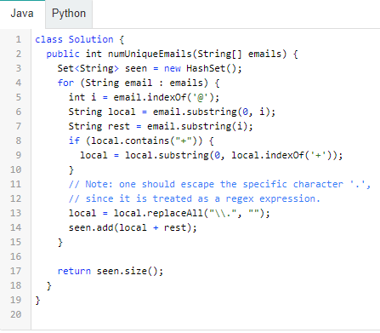

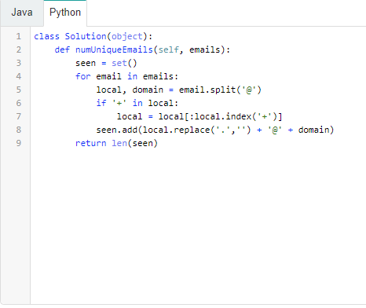

**Complexity Analysis**

* Time Complexity: O(\mathcal{C})*O*(C), where \mathcal{C}C is the total content of emails.
* Space Complexity: O(\mathcal{C})*O*(C).